Hands-on 1:
PL/SQL programming

Exercise 1: Control Structures

Table creating:

CREATE TABLE Customers (
CustomerID NUMBER PRIMARY KEY,
Name VARCHAR2(50),
Age NUMBER,
Balance NUMBER,
LoanInterestRate NUMBER,
IsVIP CHAR(1)
);
CREATE TABLE Loans (
LoanID NUMBER PRIMARY KEY,
CustomerID NUMBER,
LoanAmount NUMBER,
DueDate DATE,
FOREIGN KEY (CustomerID) REFERENCES Customers(CustomerID)
);
INSERT INTO Customers (CustomerID, Name, Age, Balance, LoanInterestRate, IsVIP) VALUES (1, 'John Doe', 65, 12000, 10.5, 'N');
INSERT INTO Customers (CustomerID, Name, Age, Balance, LoanInterestRate, IsVIP) VALUES (2, 'Alice Smith', 45, 9500, 11.0, 'N');
INSERT INTO Customers (CustomerID, Name, Age, Balance, LoanInterestRate, IsVIP) VALUES (3, 'Bob Lee', 70, 15000, 9.5, 'N');
INSERT INTO Customers (CustomerID, Name, Age, Balance, LoanInterestRate, IsVIP) VALUES (4, 'Maria Davis', 58, 5000, 12.0, 'N');
INSERT INTO Customers (CustomerID, Name, Age, Balance, LoanInterestRate, IsVIP) VALUES (5, 'Tom Clark', 61, 20000, 10.0, 'N');
COMMIT;

INSERT INTO Loans (LoanID, CustomerID, LoanAmount, DueDate) VALUES (101, 1, 50000, SYSDATE + 15);
INSERT INTO Loans (LoanID, CustomerID, LoanAmount, DueDate) VALUES (102, 2, 75000, SYSDATE + 35);
INSERT INTO Loans (LoanID, CustomerID, LoanAmount, DueDate) VALUES (103, 3, 30000, SYSDATE + 5);
INSERT INTO Loans (LoanID, CustomerID, LoanAmount, DueDate) VALUES (104, 4, 90000, SYSDATE - 10);
INSERT INTO Loans (LoanID, CustomerID, LoanAmount, DueDate) VALUES (105, 5, 100000, SYSDATE + 29);

-- Scenario 1: The bank wants to apply a discount to loan interest rates for customers above 60 years old.
BEGIN
FOR rec IN (SELECT CustomerID, Age FROM Customers) LOOP
IF rec.Age > 60 THEN
UPDATE Customers
SET LoanInterestRate = LoanInterestRate - 1
WHERE CustomerID = rec.CustomerID;
END IF;
END LOOP;
COMMIT;
END;
OUTPUT:
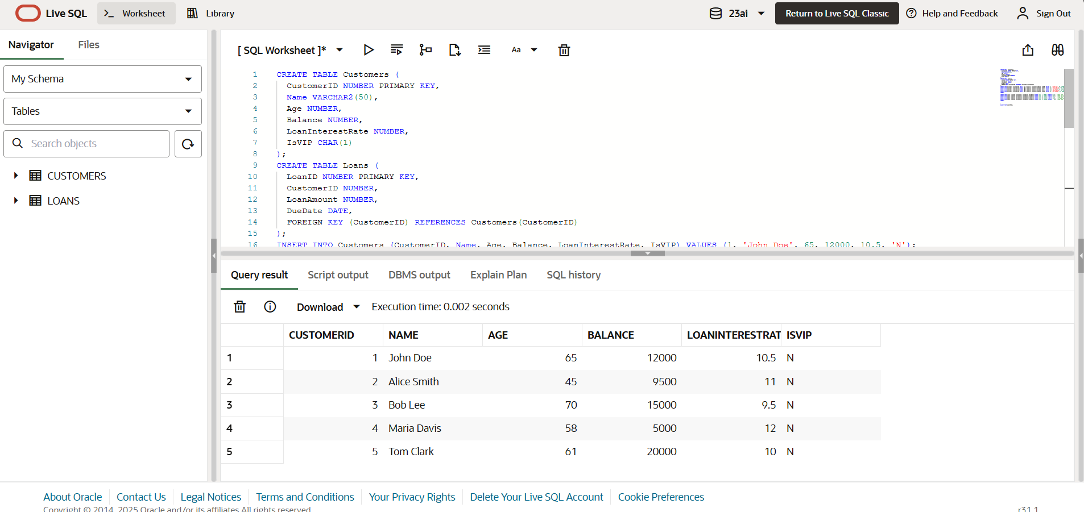
-- Scenario 2: A customer can be promoted to VIP status based on their balance.
BEGIN
FOR rec IN (SELECT CustomerID, Balance FROM Customers) LOOP
IF rec.Balance > 10000 THEN
UPDATE Customers
SET IsVIP = 'Y'
WHERE CustomerID = rec.CustomerID;
END IF;
END LOOP;
COMMIT;
END;
OUTPUT:
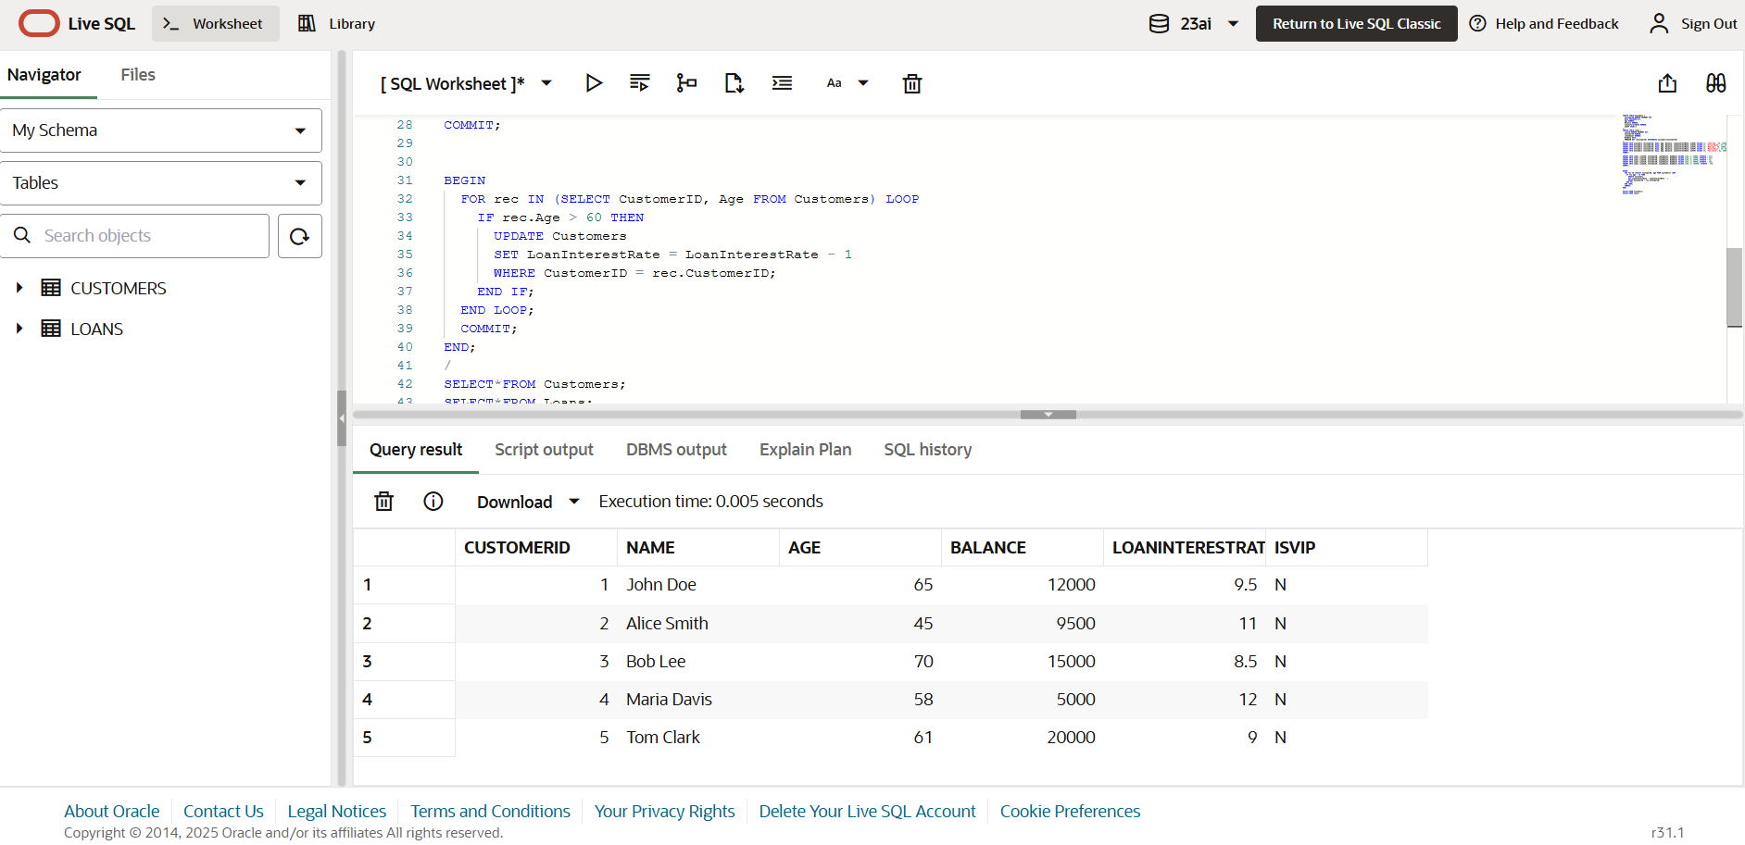
-- Scenario 3: The bank wants to send reminders to customers whose loans are due within the next 30 days.
BEGIN
FOR rec IN (
SELECT LoanID, CustomerID, DueDate
FROM Loans
WHERE DueDate BETWEEN SYSDATE AND SYSDATE + 30
) LOOP
DBMS_OUTPUT.PUT_LINE(
'Reminder: Loan ID ' || rec.LoanID ||
' for Customer ID ' || rec.CustomerID ||
' is due on ' || TO_CHAR(rec.DueDate, 'DD-MON-YYYY')
);
END LOOP;
END;
/
OUTPUT:
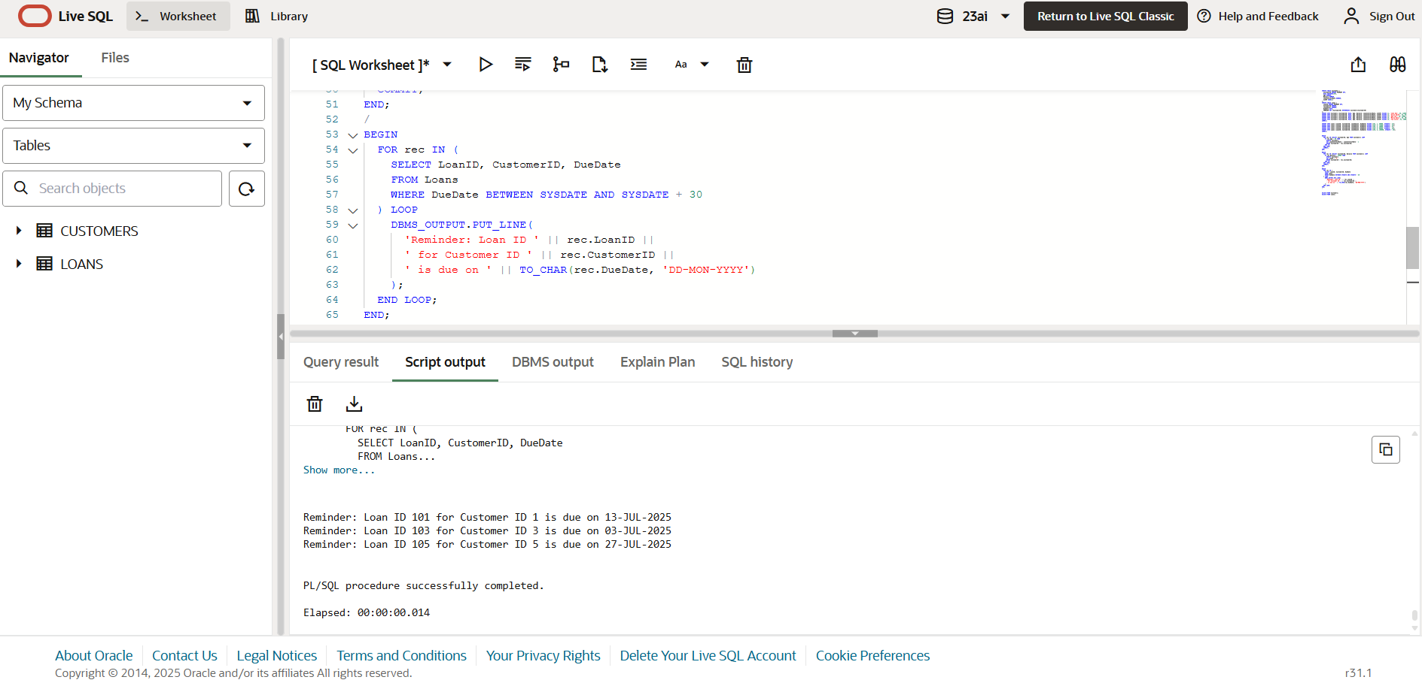
Exercise 3: Stored Procedures:
--Scenario 1: The bank needs to process monthly interest for all savings accounts.
Question: Write a stored procedure ProcessMonthlyInterest that calculates and updates the balance of all savings accounts by applying an interest rate of 1% to the current balance.
CREATE TABLE Employees (
EmployeeID NUMBER PRIMARY KEY,
Name VARCHAR2(50),
Department VARCHAR2(30),
Salary NUMBER
);
INSERT INTO Employees VALUES (1, 'Anita Sharma', 'IT', 50000);
INSERT INTO Employees VALUES (2, 'Ravi Kumar', 'HR', 40000);
INSERT INTO Employees VALUES (3, 'Priya Desai', 'IT', 60000);
INSERT INTO Employees VALUES (4, 'Sunil Mehta', 'Finance', 55000);
INSERT INTO Employees VALUES (5, 'Neha Singh', 'HR', 42000);
COMMIT;
CREATE OR REPLACE PROCEDURE ProcessMonthlyInterest IS
BEGIN
FOR rec IN (SELECT CustomerID, Balance FROM Customers) LOOP
UPDATE Customers
SET Balance = Balance + (Balance * 0.01)
WHERE CustomerID = rec.CustomerID;
END LOOP;
COMMIT;
END;

OUTPUT:
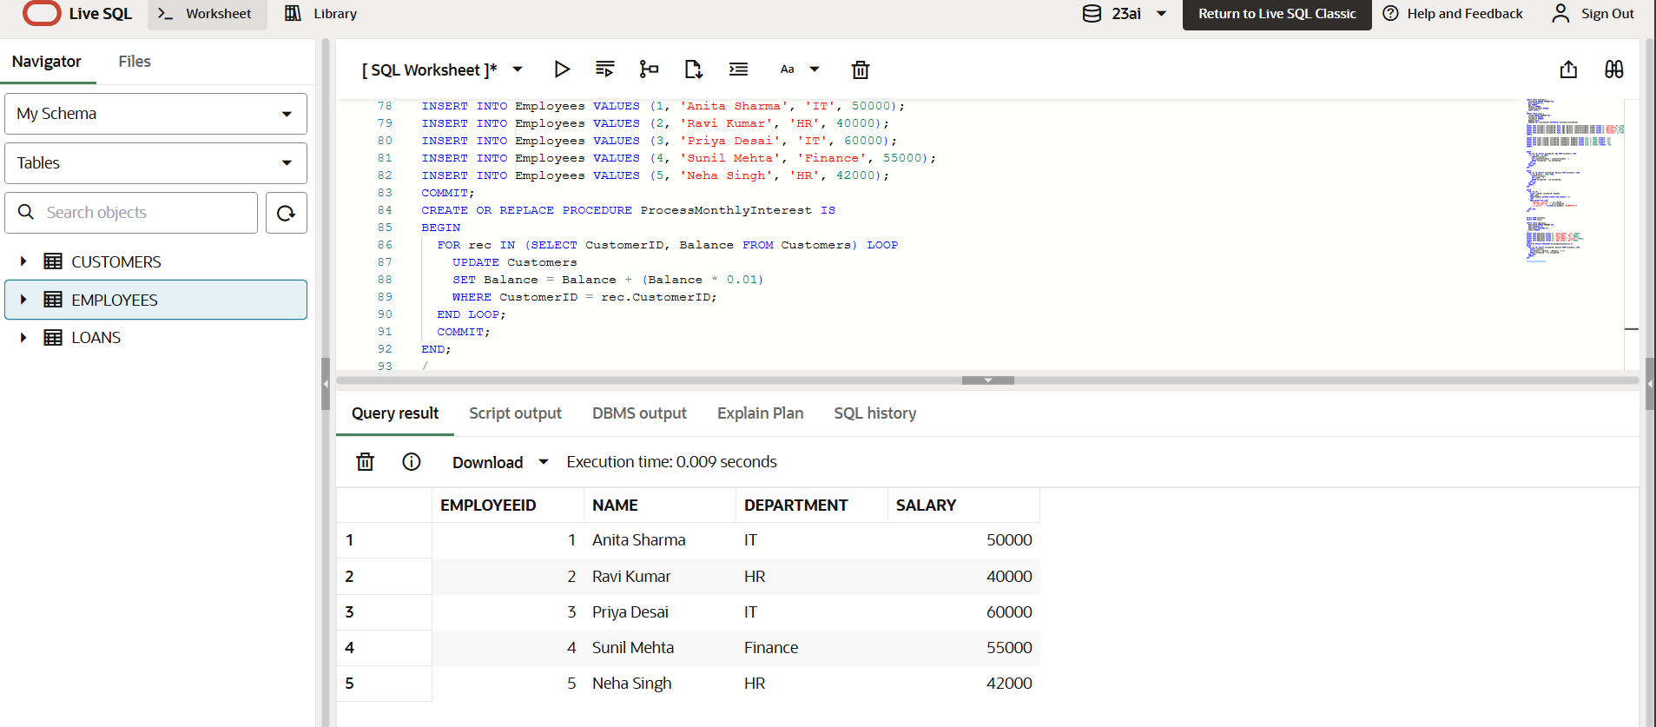

--Scenario 2: The bank wants to implement a bonus scheme for employees based on their performance.

CREATE OR REPLACE PROCEDURE UpdateEmployeeBonus (
p_department IN VARCHAR2,
p_bonus_pct IN NUMBER
) IS
BEGIN
UPDATE Employees
SET Salary = Salary + (Salary * p_bonus_pct / 100)
WHERE Department = p_department;

COMMIT;
END;
OUTPUT:
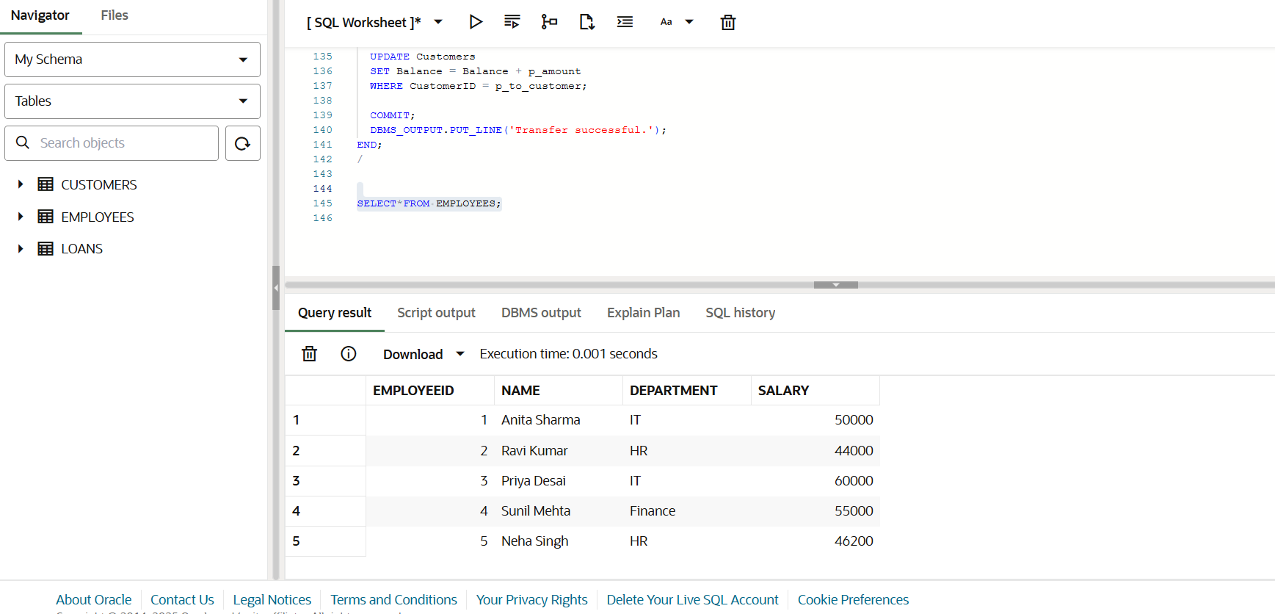
--Scenario 3: Customers should be able to transfer funds between their accounts.
CREATE OR REPLACE PROCEDURE UpdateEmployeeBonus (
p_department IN VARCHAR2,
p_bonus_pct IN NUMBER
) IS
BEGIN
UPDATE Employees
SET Salary = Salary + (Salary * p_bonus_pct / 100)
WHERE Department = p_department;

COMMIT;
END;

/
EXEC UpdateEmployeeBonus('HR', 10);

CREATE OR REPLACE PROCEDURE TransferFunds (
p_from_customer IN NUMBER,
p_to_customer IN NUMBER,
p_amount IN NUMBER
) IS
v_balance NUMBER;
BEGIN
-- Step 1: Check source balance
SELECT Balance INTO v_balance
FROM Customers
WHERE CustomerID = p_from_customer;

IF v_balance < p_amount THEN
DBMS_OUTPUT.PUT_LINE('Transfer failed: Insufficient balance.');
RETURN;
END IF;

-- Step 2: Deduct from sender
UPDATE Customers
SET Balance = Balance - p_amount
WHERE CustomerID = p_from_customer;

-- Step 3: Add to receiver
UPDATE Customers
SET Balance = Balance + p_amount
WHERE CustomerID = p_to_customer;

COMMIT;
DBMS_OUTPUT.PUT_LINE('Transfer successful.');
END;
/

OUTPUT: